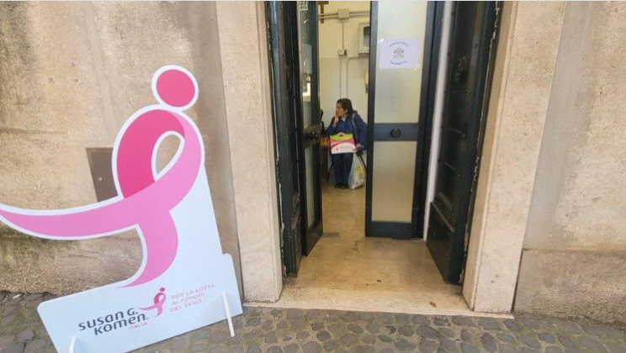
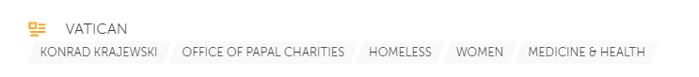

Vatican offers free cancer screening for homeless women in Rome
Under the Colonnade of St. Peter's Square, the Vatican Dicastery for the Service of Charity runs a clinic offering dozens of homeless women free screening for breast cancer, as part of an initiative with the Komen Italy association.
By Benedetta Capelli
Self-care is a thought that often does not cross the minds of people living on the streets.
It is even worse for women facing financial difficulties who are unable to access healthcare services, sometimes even to wash.

Since the beginning of his pontificate, Pope Francis has recognized this need, and responded through the Papal Almoner by creating facilities such as showers under the Colonnade of St. Peter’s, accommodations like the “Gift of Mercy” on Via dei Penitenzieri, and the “Mother of Mercy” clinic under the Colonnade.

An important synergy for women
On Thursday, April 18, the Caravan of Prevention was set up in the Vatican Square as the result of a collaboration between the Dicastery for the Service of Charity and Komen Italy.

The association is dedicated to the prevention and fight against breast cancer in synergy with the Agostino Gemelli University Policlinic Foundation IRCCS and Gemelli Isola.

The caravan will be present in the Vatican every two months to assist women in need.
A pink ribbon, the symbol of prevention and research on the most widespread cancer among women, has been placed outside the “Mother of Mercy” clinic.
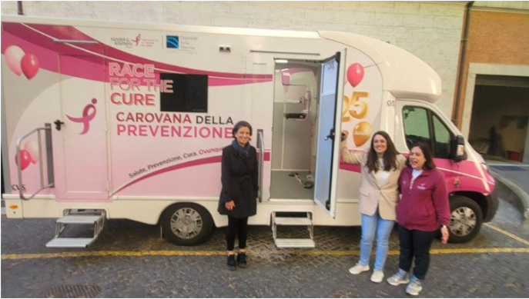Komen mobile clinic

About forty women lacking healthcare assistance, helped by the clinic and the Santa Marta Dispensary, were able to undergo diagnostic screenings for breast cancer, such as mammography and breast ultrasound.

The service was offered free-of-charge, and represented an act of care for the many women living on the streets of Rome who are the most marginalized, since cancer must be diagnosed at an early stage for effective treatment.

If any of the women were found to have breast cancer, they would be assisted with further examinations and all necessary treatments.

The clinic: a reservoir of generosity
The initiative is just one of many carried out by the “Mother of Mercy” clinic. Opened at the desire of Pope Francis, the clinic has become a functioning reality.

Since January 1, 2024, 4,429 healthcare services have been provided, including 2,054 general medical visits, 1,901 specialist visits, 115 dental visits, 359 laboratory tests conducted, and 4199 boxes of medicines delivered over 91 days of operation.

The clinic operates thanks to the benevolence of 80 doctors, nurses, paramedics, and technicians who voluntarily offer their time and professionalism to serve the most vulnerable.

